COVER PAGE
INTRODUCTION TO DATAMANAGEMENT
PROJECT REPORT
(Project Semester January-April 2025)

“MakeMyTrip Customer & Booking
Trends Dashboard”

Submitted by:
Tunga Durga Sai Prasad
(Name of student)

Registration No:12306404

Programme and Section: B tech (CSE), K23EL
Course Code:INT217

Under the Guidance of

Name Of the Faculty: Dr. Parampreet Kaur (UID:18758)
Desgination: Faculty Coordinator, Department of School Of Computing

Discipline of CSE/IT

Lovely School of Computing
Lovely Professional University, Phagwara
1. Trip Duration
Problem Statement:
➡️ What is the average duration of trips booked by customers?
Description:
This KPI measures the length of trips taken by customers, based on the difference between the start date and end date of travel.
It provides insight into customer travel behavior — whether they prefer short getaways or extended vacations — which helps in tailoring marketing and package offerings.
Analysis Approach:
- Calculate trip duration for each row using =Return_Date - Travel_Date.
- Group by destination or customer type to analyze trip patterns.
- Segment by time (e.g., monthly average trip duration).

2. Most Booked Holiday Destinations
Problem Statement:
➡️ Which destinations are the most frequently chosen by customers?
Key Metric:
- Number of Bookings per Destination
- Identifies high-demand travel locations.
Description:
This metric identifies top holiday spots preferred by travelers. It reflects user interest and demand, helping in targeted promotions and travel package planning.
Analysis Approach:
- Use a Pivot Table to count Booking IDs grouped by Destination.
- Visualize as a horizontal bar chart for ranking.
- Optionally, compare with season/month to find peak travel times.
Pivot Table:
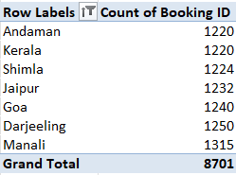
Chart Type: Horizontal Bar Chart

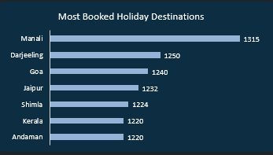

3. Most Preferred Hotels by Users
Problem Statement:
➡️ Which hotel chains or properties are most frequently booked by users?
Key Metric:
- Number of Bookings per Hotel
- Shows customer preference for hotels, helps partner prioritization.
Description:
Tracks customer preference for hotel brands, allowing insights into hospitality partnerships, brand popularity, and service quality expectations.
Analysis Approach:
- Filter only confirmed hotel bookings (Hotel Booked = Yes).
- Count Booking IDs grouped by hotel names.
- Visualize using a vertical bar chart to show comparisons.
Pivot Table:
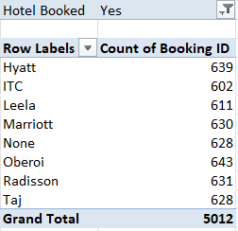
Chart Type: Vertical Column Chart

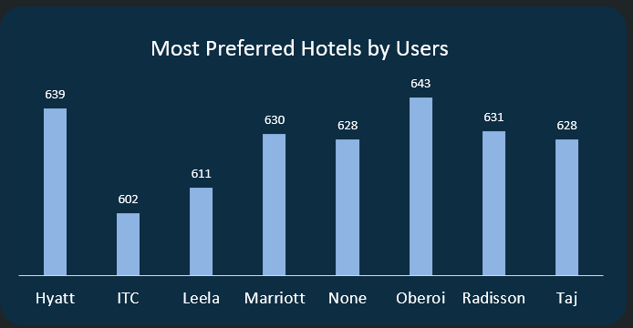
4. Booking Status Summary
➡️ What is the overall distribution of booking statuses (e.g., Confirmed, Cancelled, Pending)?
Description:
This KPI gives a snapshot of booking outcomes. It helps identify issues in booking processes and areas for service improvement.
Analysis Approach:
- Count Booking IDs by Booking Status using a Pivot Table.
- Use a donut or pie chart for clear visualization.
- Calculate percentage distribution (Confirmed %, Cancelled %, Pending %).
Pivot Table:
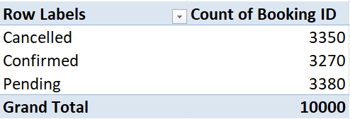
Chart Type: Donut Chart

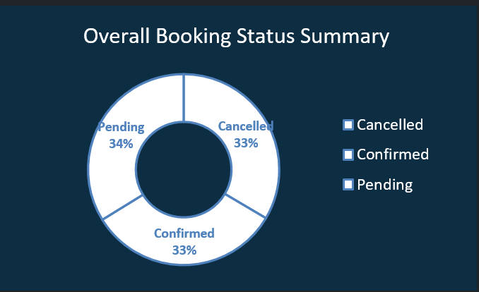

5. Promo Code Usage Summary
Problem Statement:
➡️ How often are different promotional codes used during bookings?
Description:
This measures the effectiveness of marketing campaigns and discounts. Higher usage indicates successful outreach and pricing strategies.
Analysis Approach:
- Count Booking IDs by Promo Code.
- Display results using a bar chart.
- Compare usage to booking values or destinations to assess campaign ROI.
Pivot Table:
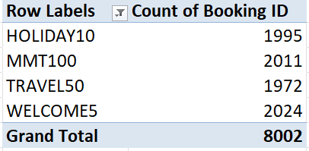
Chart Type: Vertical Bar Chart

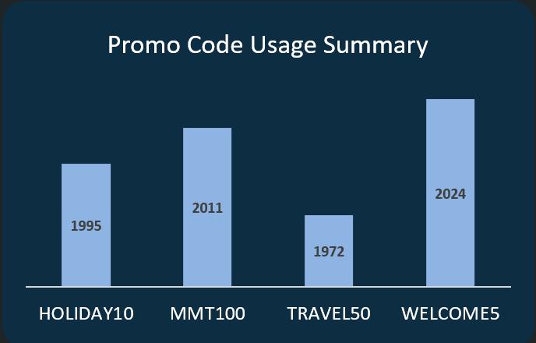
6. Average Trip Duration
Problem Statement:
➡️ What is the average number of days customers spend per trip?
Key Metric:
- Average Number of Days per Trip
- Gives insight into customer travel behavior.
Description:
This reveals customer travel behavior and trip preferences. It's valuable for planning packages, hotel stays, and transport options.
Analysis Approach:
- Calculate trip duration using =End Date - Start Date.
- Use Pivot Table to average durations by Destination.
- Visualize trends using a line chart or destination-wise bar chart.
Pivot Table:
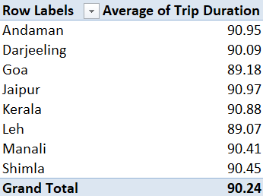

Chart Type: Line Chart

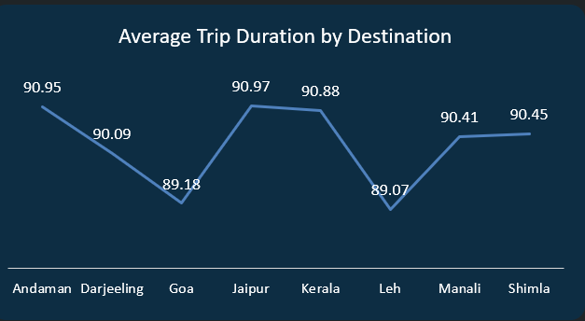

7. Average Ticket Price by Mode of Transport
Problem Statement:
➡️ What is the average cost of tickets for each transport mode across destinations?
Key Metrics:
- Average Fare per Transport Mode (Flight, Train, Bus, etc.)
- Helps compare cost trends across transport types.
Description:
Helps assess pricing trends and customer cost sensitivity for different travel modes (Bus, Train, Flight, Car Rental).
Analysis Approach:
- Use Pivot Table with Destination as Rows and Transport Mode as Columns.
- Use Average of Ticket Fare for each mode.
- Visualize using a clustered bar chart.
Pivot Table:
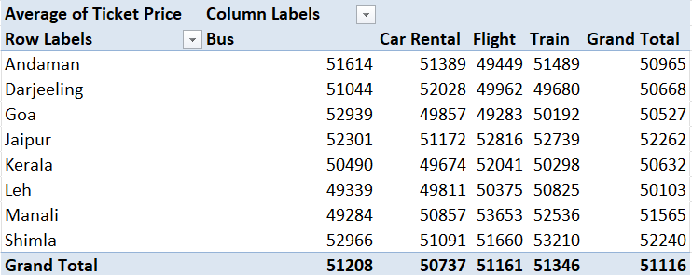
Chart Type: Clustered Column Chart

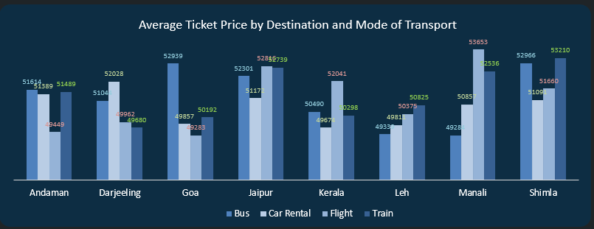

8. State-Wise Booking Count Summary
Problem Statement:
➡️ Which Indian states have the highest number of bookings made through MakeMyTrip?
Description:
This visualization highlights the geographical distribution of bookings across Indian states. It helps identify the strongest regions for customer engagement and reveals where demand is high or low, allowing targeted regional marketing.
Chart Type: MAP
